Name: Sherri Begay School: Park Elementary
Date and Time: February 24, 2020 @ 10:05-11:30 a.m Lesson Duration: 85 min.
Grade: 3rd Grade Lesson Title: Earth Science
CO Academic Standards
S.3.3.Earth and Space Science. Climate describes patterns of typical weather conditions over different scales and variations; historical weather patterns can be analyzed.
Evidence Outcome:
Obtain and combine information to describe climates in different regions of the world. (3-ESS2-2)
Objective(s):
By the end of the lesson, students will be able to describe the different features of the 5 regions of the United States and explain the Colorado region
Learning Target(s):
I can show wonder and perseverance to distinguish the 5 regions of the United States by different features they have.
Criteria for Success:
- Look + Listen=Learn
- Look at region board and complete worksheet
- Write down interesting fact from a different region and share

Assessment
- Sticky notes
- Region Worksheets
- Questioning
- Thumbs up/Thumbs down

Materials
- Pencil
- Picture of the United States with the 50 states and a picture of the U.S with the regions
- Doc Cam
- Sticky Notes
- Region Worksheets
- Region Tag Boards

Inquiry Questions or Big Picture Statement
- What region is Colorado in?
- Why do you think Colorado is in the West region?
- What features does the West region have that are different from the other regions?

Step-by-step Lesson

INTRODUCTION (20 min.)
-Have students sit in a “blob island” near the board
-Remind students about the “done” club and to be respectful 3rd graders
-Have students read the learning target for science
-Explain to students that we are starting a new science unit
-Show a picture of the United States that has the 50 states
-Then show students a map of the United States that has the outlines of the regions on the doc cam (5 regions)
-Explain to student’s what region means and write definition on the board. Region- are made up of different places that are alike.
-Explain the United States and how we have 50 states that are divided into different regions
-Explain, “There are 5 regions in the United States, the West region covers Washington, Idaho, Montana, Wyoming, Colorado, California, Utah, Alaska, the Southwest region covers Arizona, New Mexico, Texas, and Oklahoma, the Midwest region covers North Dakota, South Dakota, the Southeast regions covers Florida, Alabama, South and North Carolina, Louisiana, and the Northeast region covers New York, Maine, New Hampshire, New Jersey, etc.”
-Explain that “We are going to be discovering different regions today, you will each have a different region at each table. The fifth region will be at the horseshoe table since we only have 4 tables, I will have the students that sit at the end of the tables sit at the horseshoe table.”
-Explain that each table will have a different worksheet that goes along with their region that they will need to fill out. They will have 15 mins to complete their worksheet.
-Check for student understanding, thumbs up/thumbs down. Explain and answer any questions students have
-I will have the student helper call out tables one by one. Remind students to have a level 0 voice as they sit down. One person from each table will get their worksheets and they pass each member a worksheet and get started.
-Remind students they have 15 mins to work

MAIN INSTRUCTION (40 min.)
-As students are filling out their region worksheet, I will walk around the class to make sure everyone is on task. Verbally recognize positive behaviors, “this table is working together to get done.”
-Keep the pictures of the regions on the board so students can see
-When 15 mins are up, stop everyone with “Macaroni and Cheese!” S:” Everybody Freeze!”
-Explain the next thing they will need to do, “Everyone, we are going to switch gears. You are going to get a sticky note and you are going to walk around the room to other regions and write one thing that was you found interesting. After you have written down your note, you can have a seat at your table or continue to walk around until its time.”
-Model for students how to do it
-“Like if I’m walking around, then I walk to the southeast region and found something interesting, am I going to stop and write it? No, I’m going to walk around the room and look at all the regions, then I will decide which one was most interesting to me. I’m not going to pick from my region, I will pick from a different region. But don’t spend too much time at one region, because we don’t have that much time.”
-“MAKE SURE YOU WRITE DOWN YOUR REGION AT THE TOP OF YOUR STICKY NOTE THAT YOU FOUND INTERESTING. Don’t forget to write your name.”
-Explain they have 15 mins to walk around the room. After they’ve written down their note, they can have a seat at their table.
-“I have placed sticky notes at each of your tables, make sure each person at your table gets one and then you can start walking. This is a level 2.”
-As students are walking around, I will write down my own interesting fact.
-Make sure each student is on task and working at a level 2

DEBRIEF (25 min.)
-Once 15 mins is up, say “Hocus Pocus!” S: “Everyone Focus!”
-Ask if everyone has put one sticky note up on the map, thumbs up/thumbs down
-Everyone has thumbs up, they will all sit down at their tables
-Say, “Now that everyone has walked around and looked at different regions, we are going to share what we found interesting. After you say what you found out loud, you will put your sticky note on the map and sit back down.”
-Model: “Let me start, I found something interesting about the …region and wrote my name on it. …….. now I will put my sticky on the …region and sit back down.”
-Start with one table and everyone will go at that table and continue to the next table.
-After everyone has place their sticky note on the board. Its time to clean up and their worksheet will go in the tub.

Differentiation
- Students can raise their hand for extra support or question’s, and I will help them
- Give F a timer so they can stay on task
- Give student’s the option to work together or alone
- Put a 0 for M for behavioral reminders and a 1 for positive behavior

Name: ___________________________ Date: _____________________
WEST REGION
Write the name of the state on the correct line.
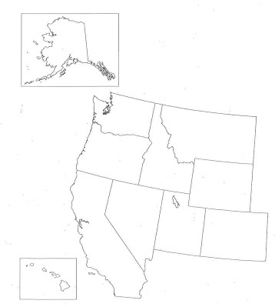

Which picture shows the type of landform that covers MOST of West region?
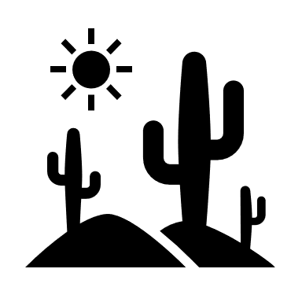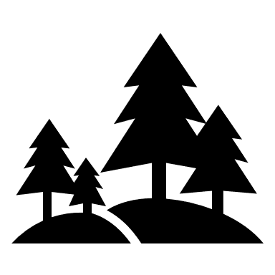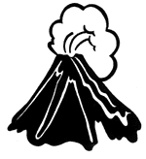
Name: ________________________________ Date: _______________________
Southwest Region
Write the name of the state on the correct line.
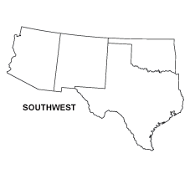

The Southwest region includes all the following states except ___________.
- New Mexico
- Texas
- Colorado
- Arizona
- Oklahoma

The Southwest borders with what other country?
- Spain
- Mexico
- Africa
- Canada

Name: ______________________________ Date: ____________________
NORTHWEST REGION
Write the name of the state on the correct line.
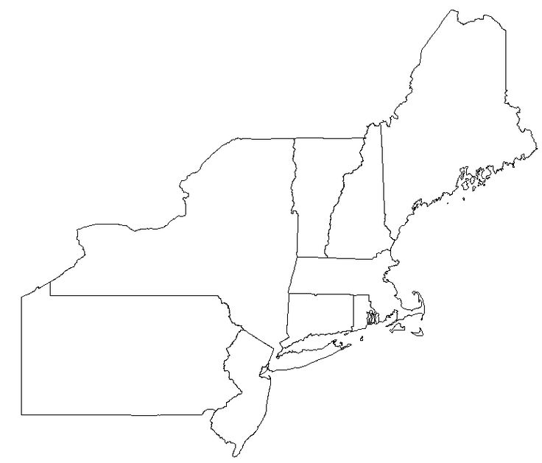

Name: _______________________________ Date: ________________________
SOUTHEAST
Write the name of the state on the correct line.
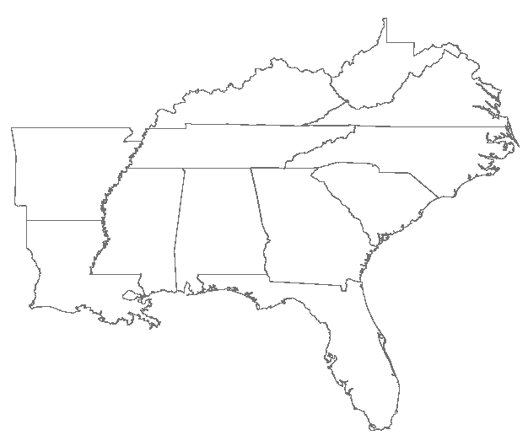

Name: _____________________________ Date: _______________________
MIDWEST REGION
Write the name of the state on the correct line.
